**User Interface Design**

**User navigation:**

Figure 1 is a flow chart showing how users can navigate through the program.

Figure Flow chart of program screens

Start app

Login

Sign-up

View saved tours

Menu start new tour/ View saved tours

Map/tour view

Starts the Application

If not a member press sign up

If a member login

After creation of the new user automatic to menu screen

Press home to return to menu

Press home to return to menu

Press start tour to go to the main tour view or press view saved tours to go to the saved tours screen

**GUI Design:**

The diagrams below are not the final designs for the program and are used as a basic guide to what the program will look like they are subject to change. Most screens contain a home button returning the user to figure 4.

**Login screen:**

Figure Login screen

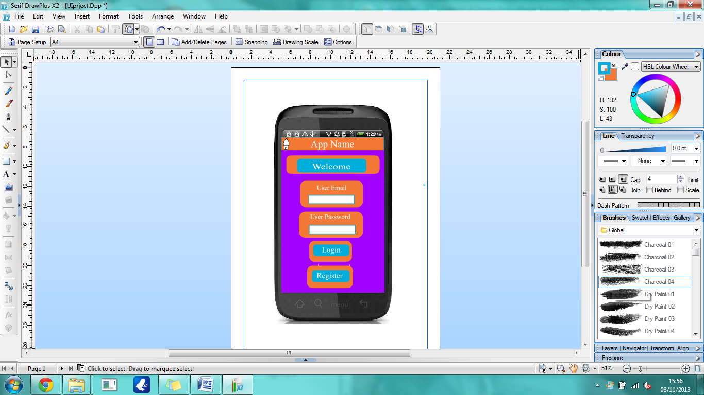

Figure 2 is the login screen this is the first screen the user will see when they start the app. It will contain the name of the app a welcome message and options for the user to either login or register to the app.

**Register screen:**

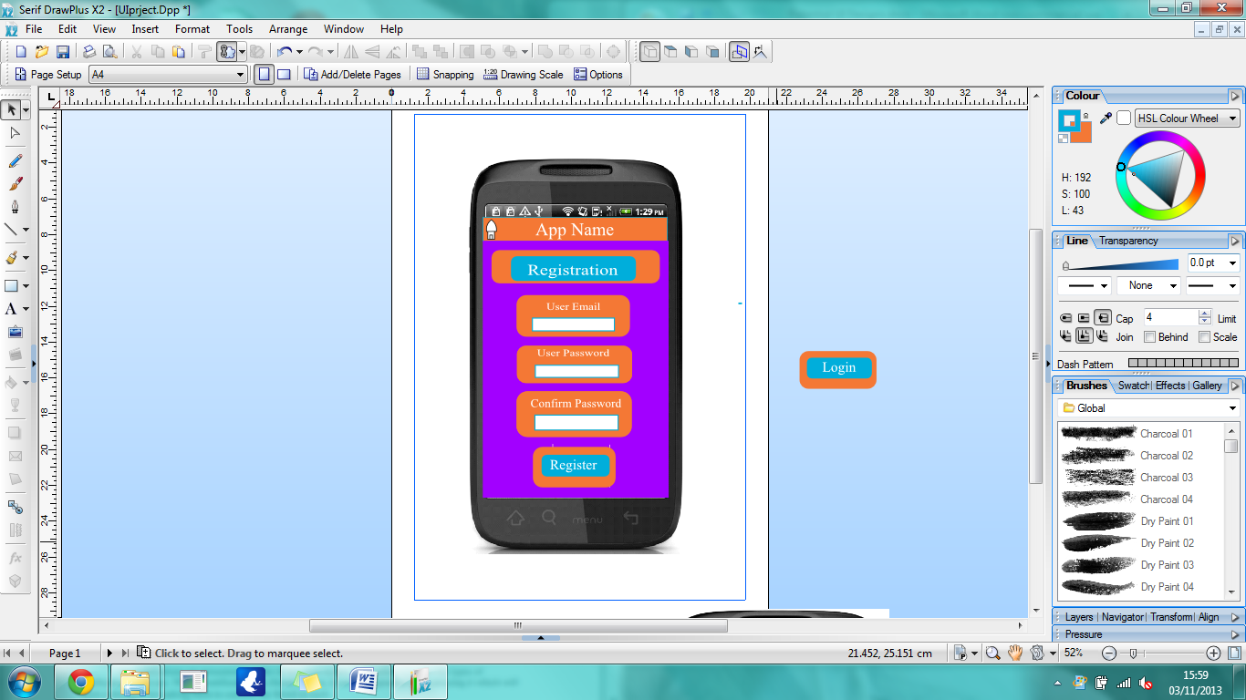

Figure Registration screen

Figure 3 is the registration screen this is where new users sign up to the app. It will contains fields allowing the users enter their email and password as well as confirm their password and finally register to the app.

**Menu screen:**

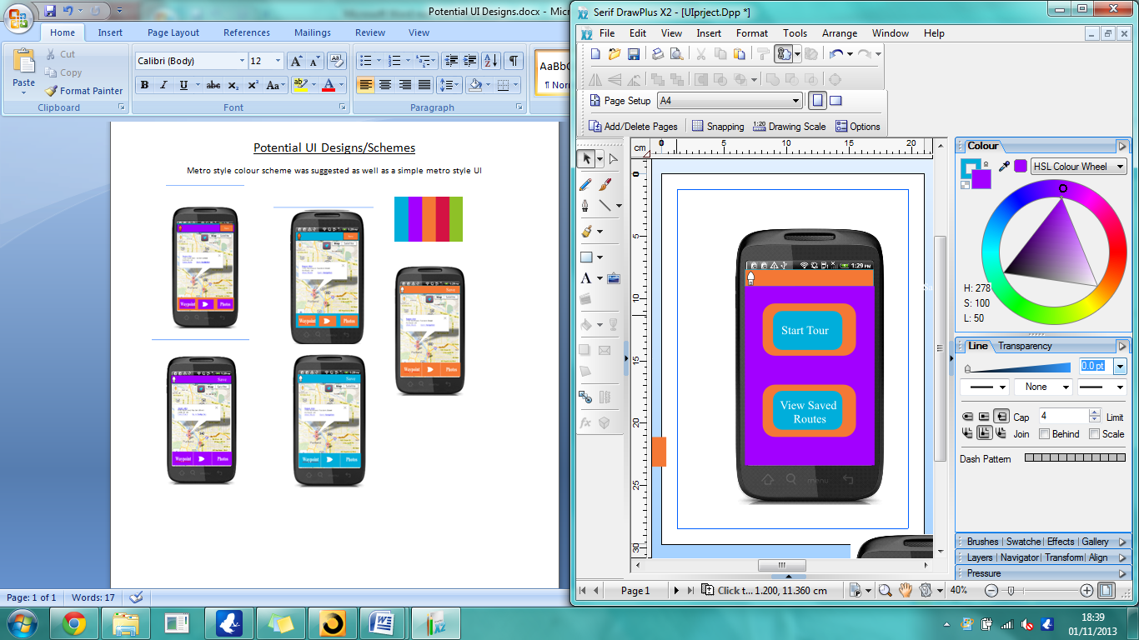

Figure Menu screen

Figure 4 is the menu screen this is where the user decides whether to start a new tour or to look at/go on, a previously saved tour.

**View saved tours Screen:**

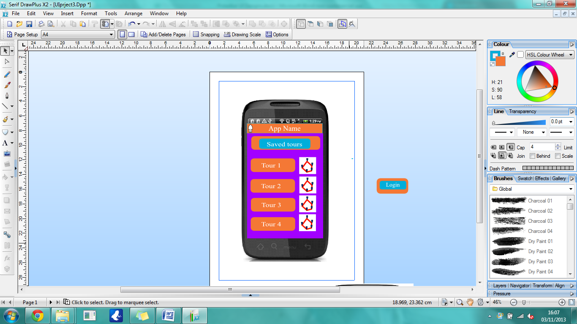

Figure Saved tours Screen

Figure 5 is the view save tours screen this is where the user can look at previously saved tours and load them on to their map following a tour that’s been saved.

**Main tour screen:**

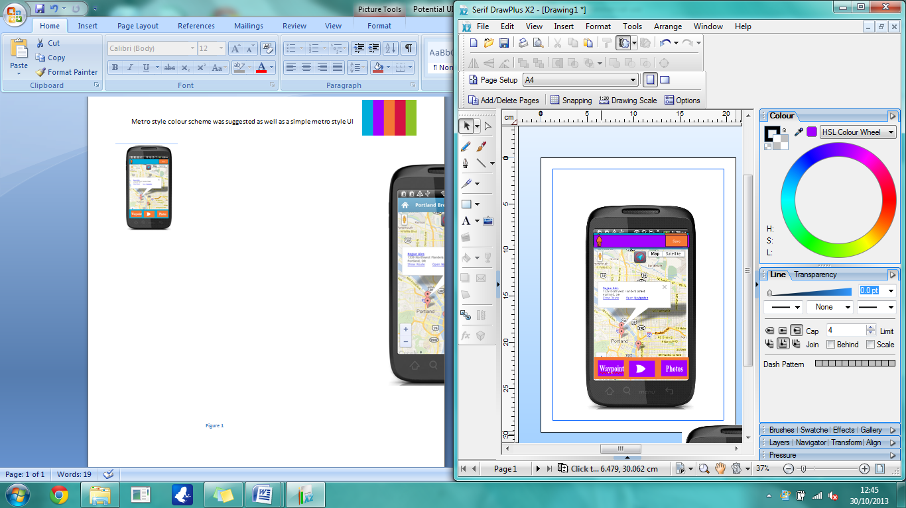Figure 6 is the tour screen this is where the app uses GPS to track a user’s location allowing them to create tours of routes they have walked or follow a saved tour. From this screen the user can add waypoints to the tour via the waypoint button which brings up a small text field where the user can add information about the waypoint. A start/stop button in the centre to allow the user to start or stop the GPS tracking of the tour with the option to save the tour or delete it. A photos button allowing users to add photos from there saved storage or to take a photo and add it to the route with an option to add a description of the photo. On the top bar there’s a home button taking the user back to figure 4 and a save button to send the tour to the server.

Figure Tour screen